**Solution Architecture**

|  |  |
| --- | --- |
| Date | 25 Novemebr 2022 |
| Team ID | PNT2022TMID51361 |
| Project Name | **Exploratory Analysis of RainFall Data in India for Agriculture** |
| Maximum Marks | 2 Marks |

Iterative

design

would

allow

other

modules

or

features

to

be

added

in

the

near

future

that

suits

the

upcoming

requirements

The

predicted

output

would

be

helpful

not

only

to

the

farmers

but

also

to

people

in

other

sectors

Features

are

selected

from

authenticated

data

and

scaled

to

predict

with

high

accuracy

Region

or

zone-based

rainfall

prediction

for

prior

decision

making

and

planning

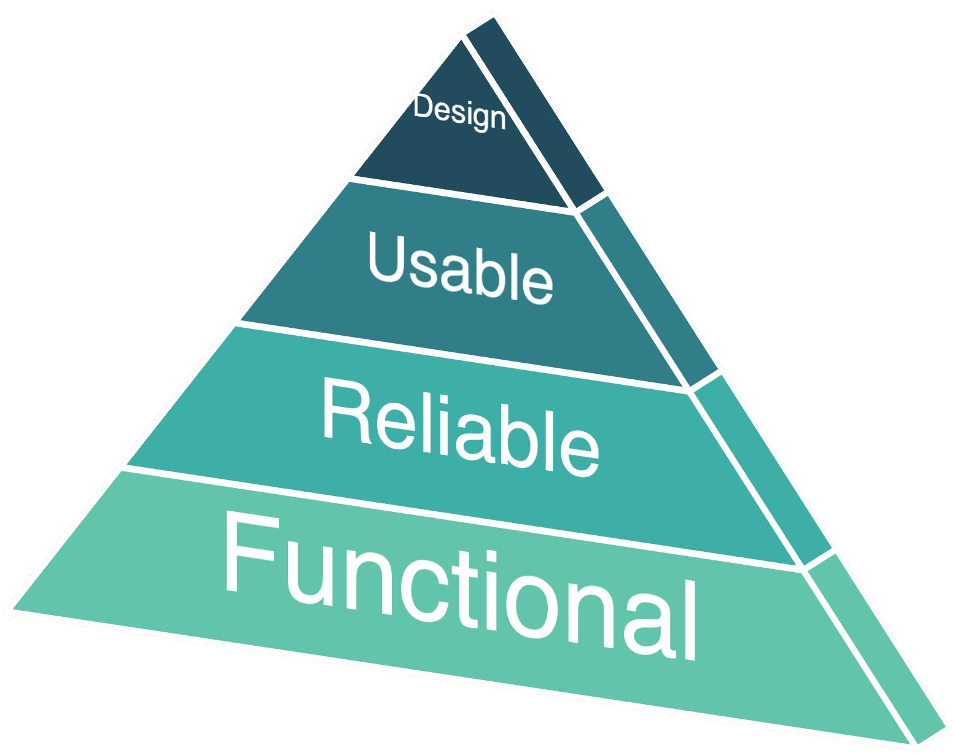

**Minimum**

**Viable**

**Architecture**

**:**

Diagrammatic Structure ofMVP:



Visualization

Data

Analysis

Rainfall

Data

[

.csv

file]

Dashboard

Rainfall

Prediction

Window

User

Inputs

Information

Centre

[

Home

Page]

Algorithm

train

&

test

Data

Preprocessing

User

feedback

&

support

User

guide

&

other

information

User

Interface

Predicted

Output

Model

f

e

a

t

u

r

e

s

e

l

e

c

t

i

o

n

&

e

x

t

r

a

c

t

i

o

n

d

i

s

p

l

a

y